[55958- Aman Goswami, Documentation-1 Date-12 Dec 2025]
Software Development Life Cycle
SDLC – Software Development Lifecycle
The Software Development Lifecycle (SDLC) is a structured process that development teams follow to build high-quality software. It ensures that every stage—from understanding the requirements to deploying and maintaining the application—is executed in a planned and organised manner.
1. Requirement Document
This is the starting point of any project.
Here, the Product Owner (PO) or client shares:
- Detailed requirements in text form
- Wireframes or rough sketches of the screens
- A high-level abstract explaining what the product should achieve
Goal: Understand “What needs to be built?” clearly before development begins.
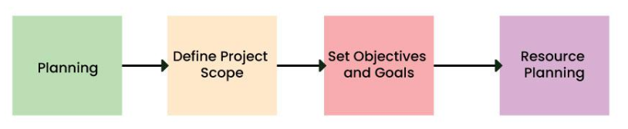
2. Technical Document
Once the requirements are finalised, the Technical Lead (TL) or Architect prepares a detailed technical design document.
This includes:
- Number of classes and their responsibilities
- Interfaces, inheritance structure
- Application modules and their interactions
- Components and internal architecture
The document usually goes through multiple reviews to ensure the design is scalable, maintainable, and aligned with requirements.
Goal: Create a strong blueprint of “How will it be built?”
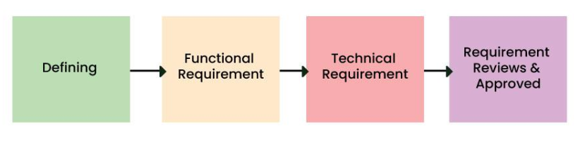
3. Coding Phase
After the design is approved, developers (SSEs, SEs) begin writing the actual code.
Key activities include:
- Building individual features and modules
- Writing clean, testable, and optimised code
- Following coding standards and best practices
- Performing peer reviews to maintain code quality
Goal: Convert design into a working software product.
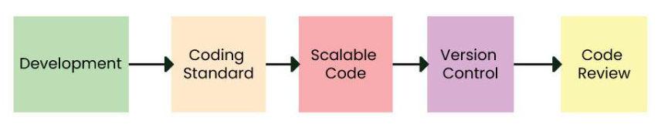
4. Testing Phase
Once development is completed, the code is moved to the QA Server.
QA Engineers perform:
- Functional testing
- Integration testing
- Usability testing
Whenever they find issues, they raise bugs so developers can fix them.
Goal: Ensure the application works correctly and meets requirements.
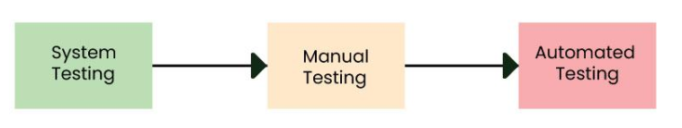
5. Staging Environment
After QA approves the build, it moves to the Staging Environment.
Here, more advanced testing is done:
- Regression testing (to ensure old features still work)
- Load testing (to check performance under heavy traffic)
- Automation test cases execution
This environment is very close to production and helps identify any last-minute issues.
6. UAT Environment (User Acceptance Testing)
In this phase, the client or end users test the application themselves.
They verify:
- Whether the system behaves as expected
- If it solves their real business problems
- Any improvements they want before release
Only after UAT approval, the product can move to the next stage.
7. PPE — Pre-Production Environment
This is a mirror copy of the live production system.
Its purpose:
- To perform a final round of checks
- Validate deployment scripts
- Ensure no technical gaps remain
It is the last safety check before going live.
8. PE — Production Environment (Go Live)
The final approved version is deployed to the Production Environment, where real users can access the system.
This is known as the Go Live stage.
Goal: Make the application available to actual users.
9. Bug Fixing & Maintenance
Even after the software goes live, the team continuously maintains it by:
- Fixing reported issues
- Releasing patches and performance improvements
- Adding new features based on user feedback
Maintenance ensures that the software remains stable, secure, and up to date.
